Evidence - Aerial Photo 1
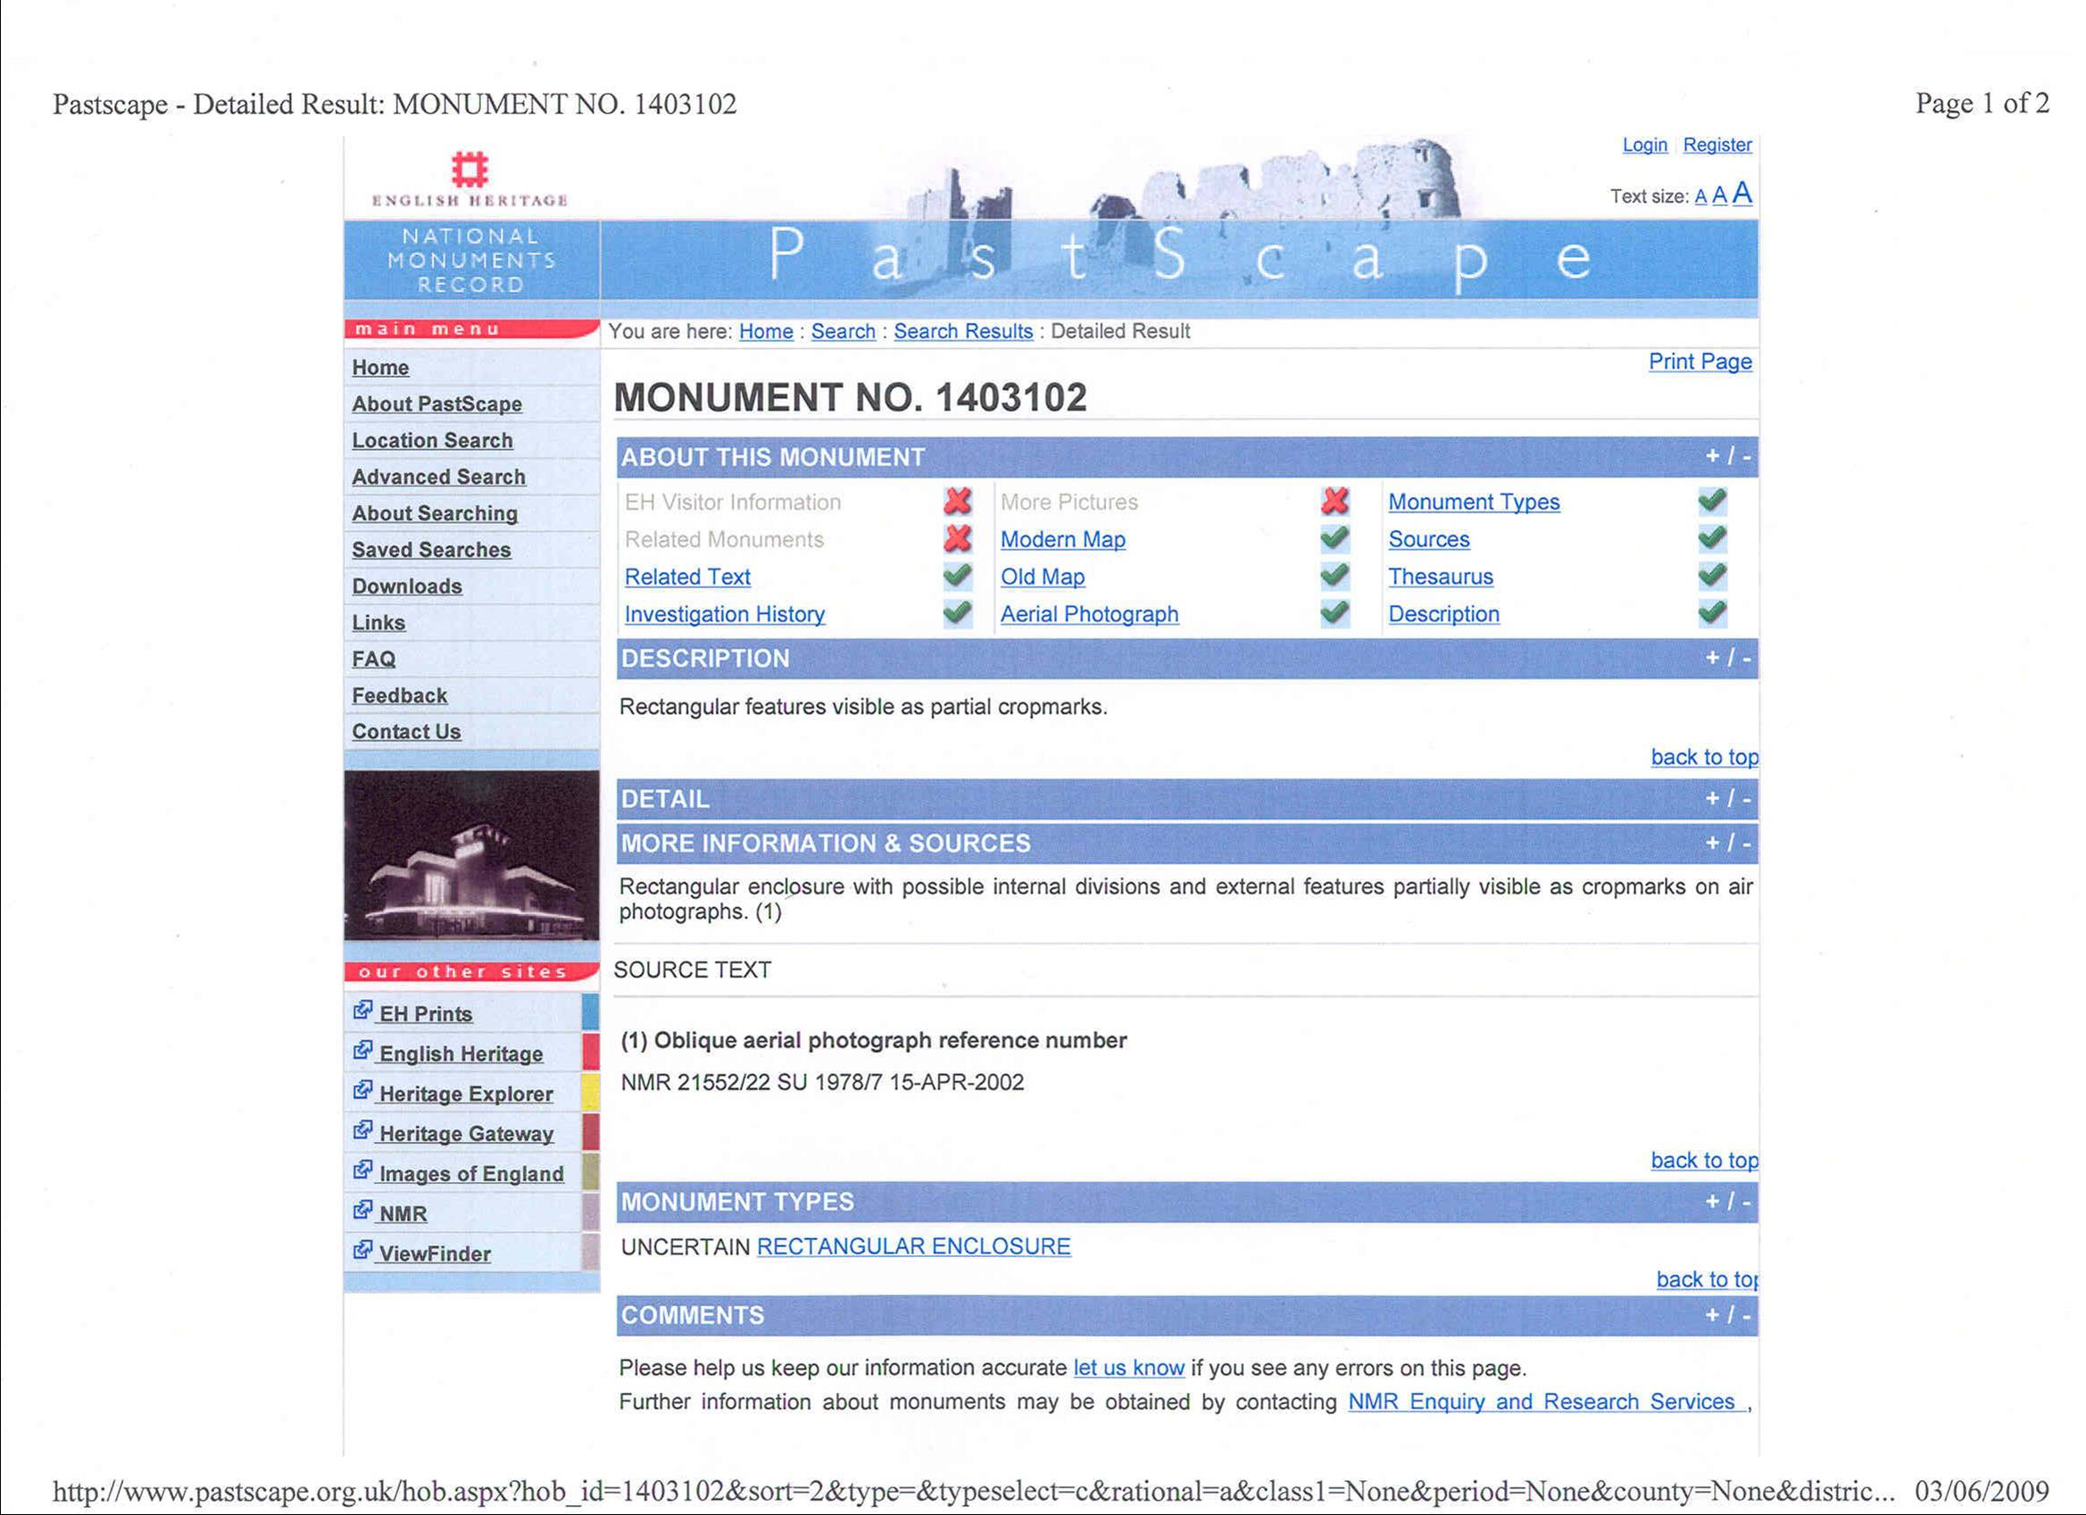

Evidence - Aerial Photo 1
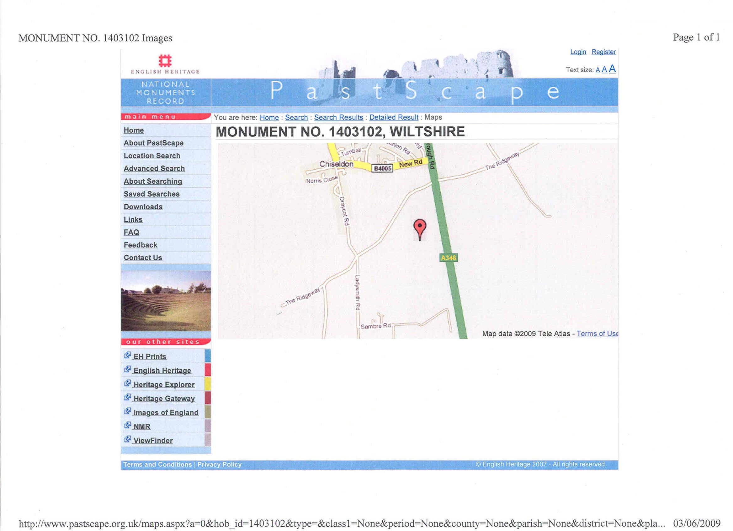

Evidence - Aerial Photo 1
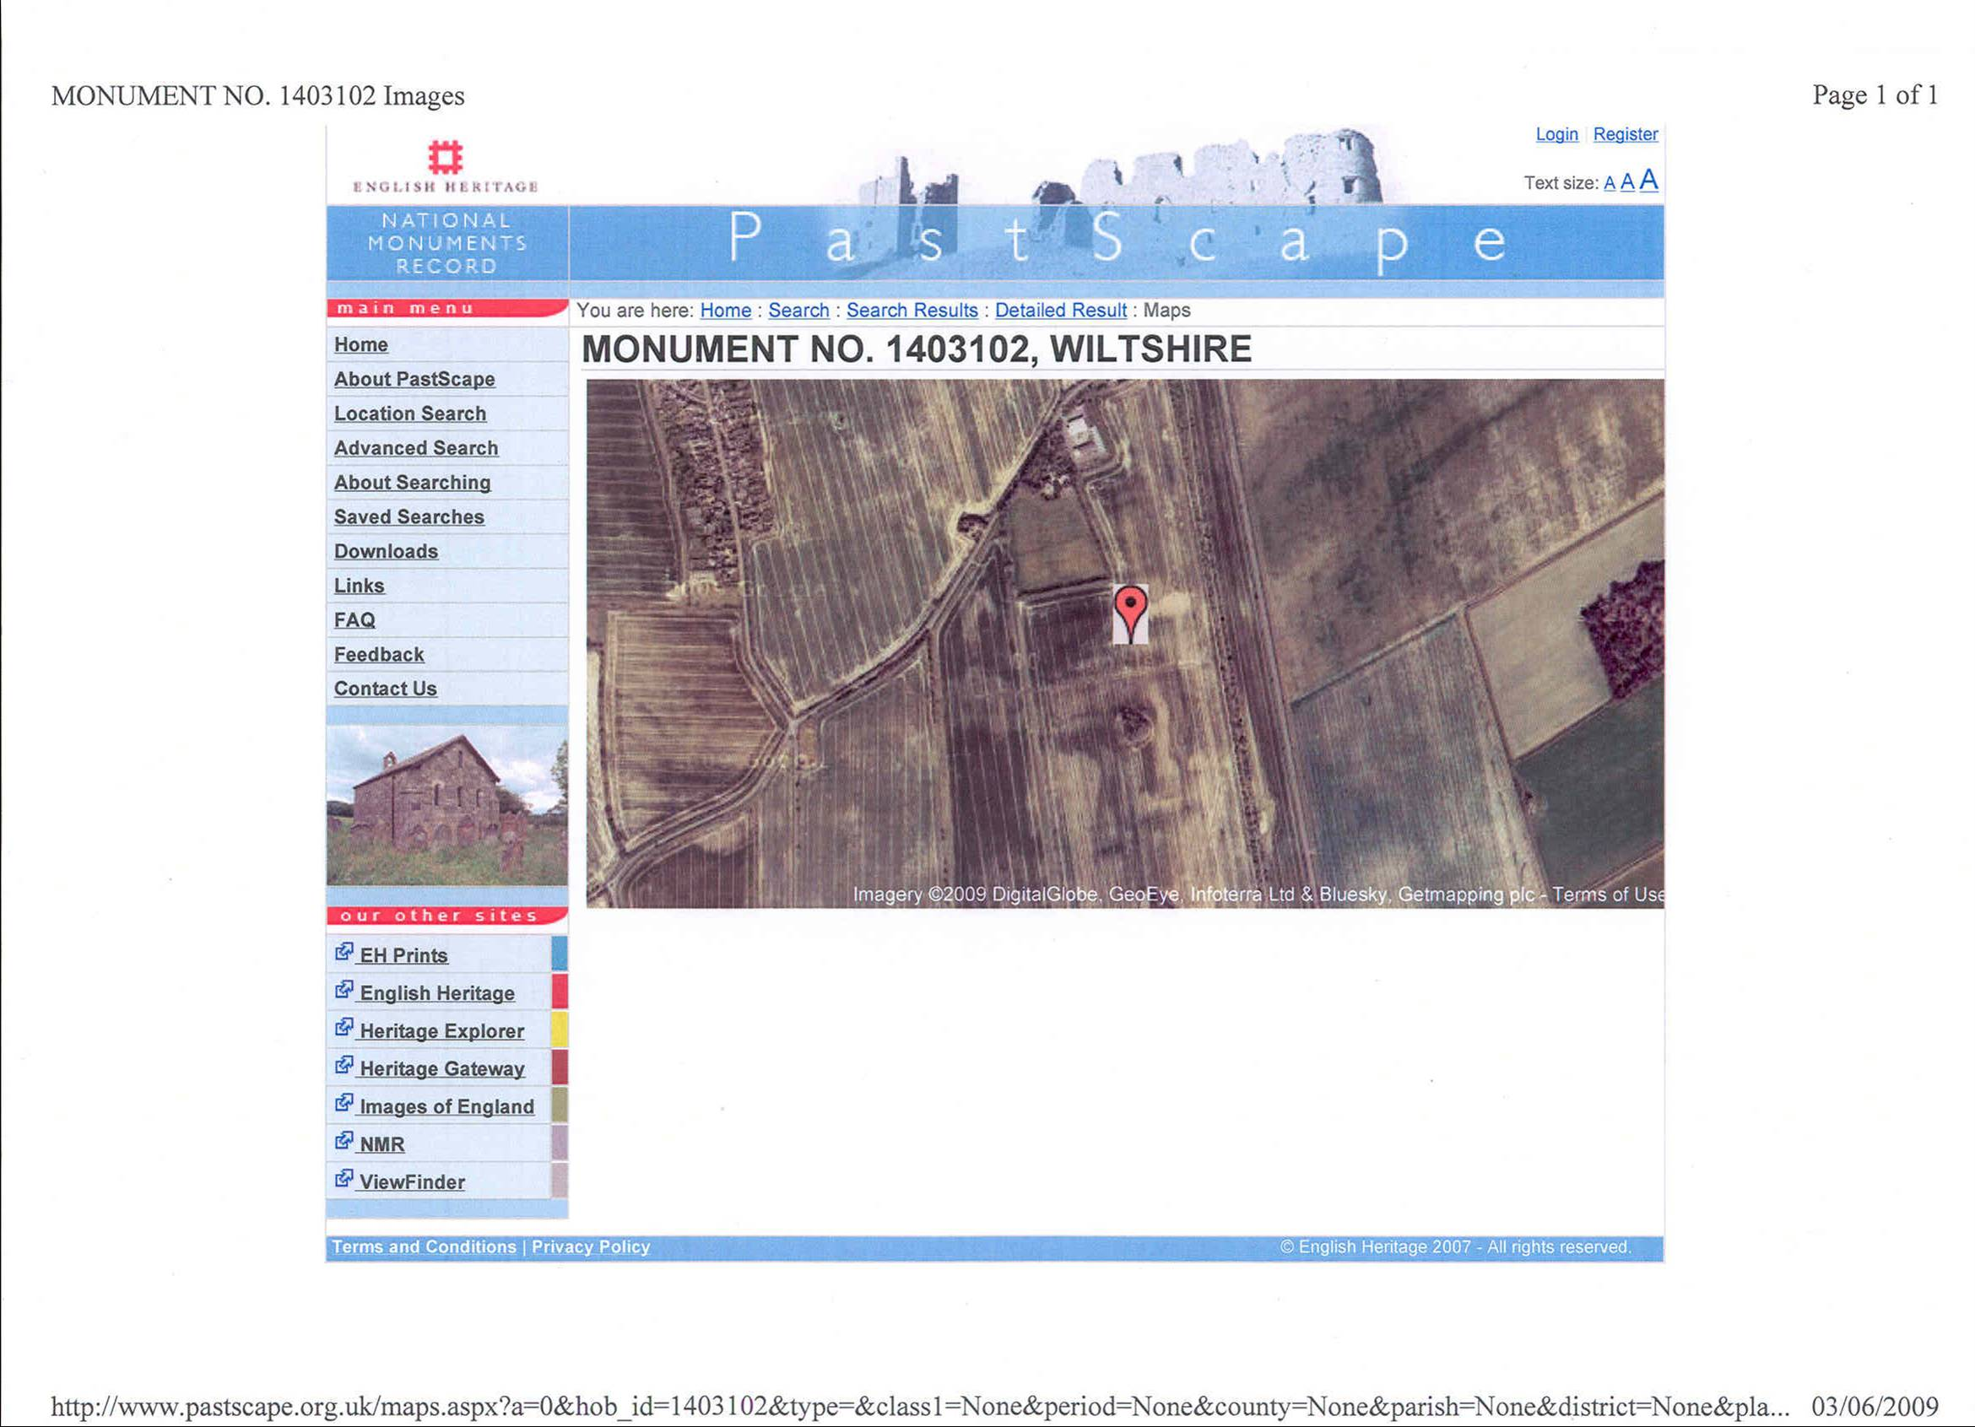
Evidence – Aerial Photo 2
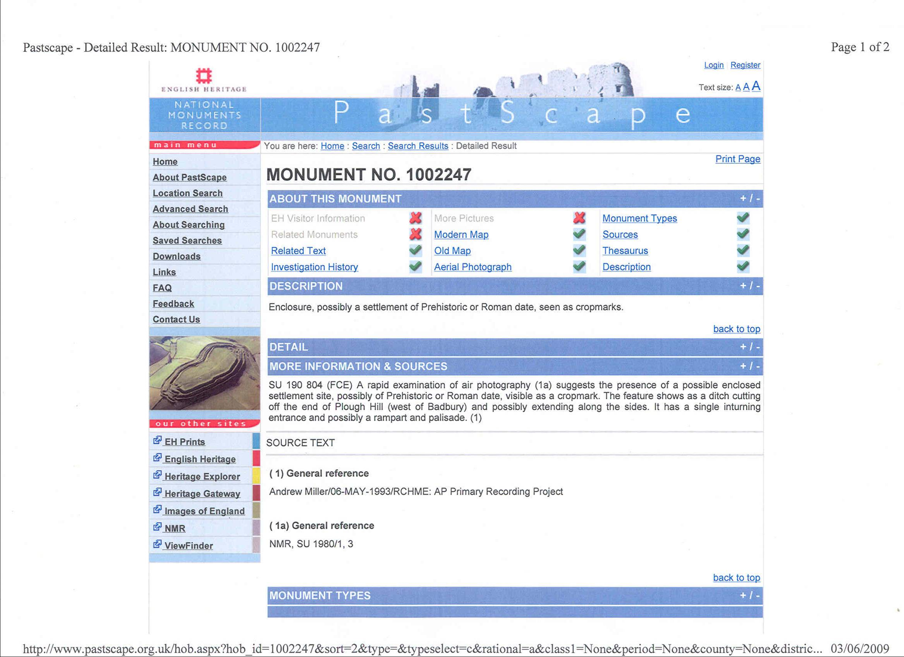
Evidence – Aerial Photo 2
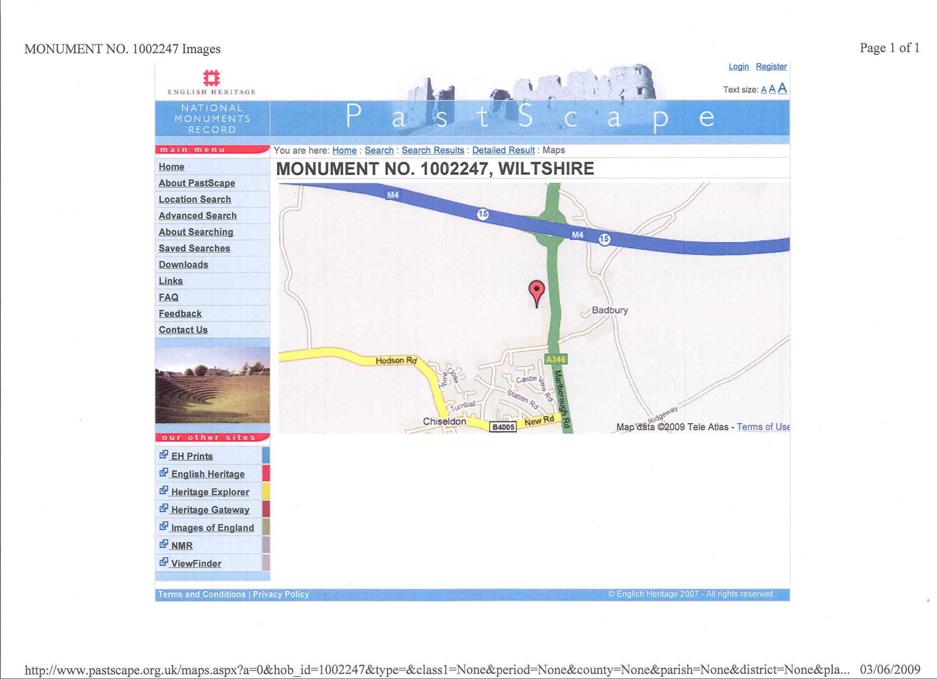
Evidence – Aerial Photo 2
