Evidence – Archaeological Finds 1
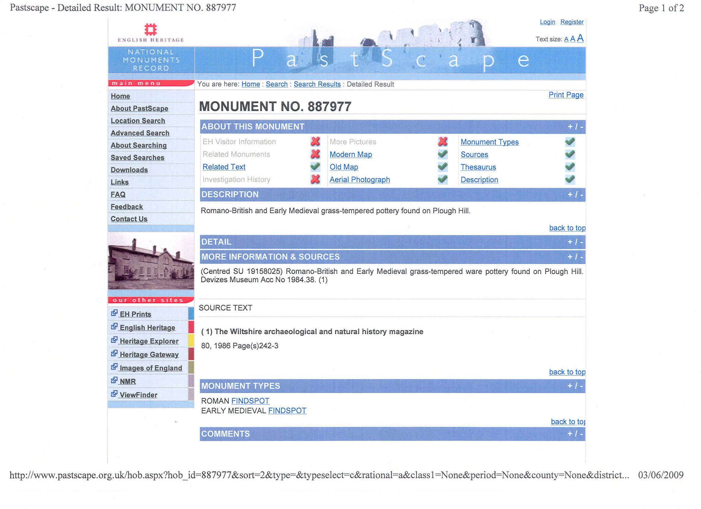

Evidence - Archaeological Finds 1
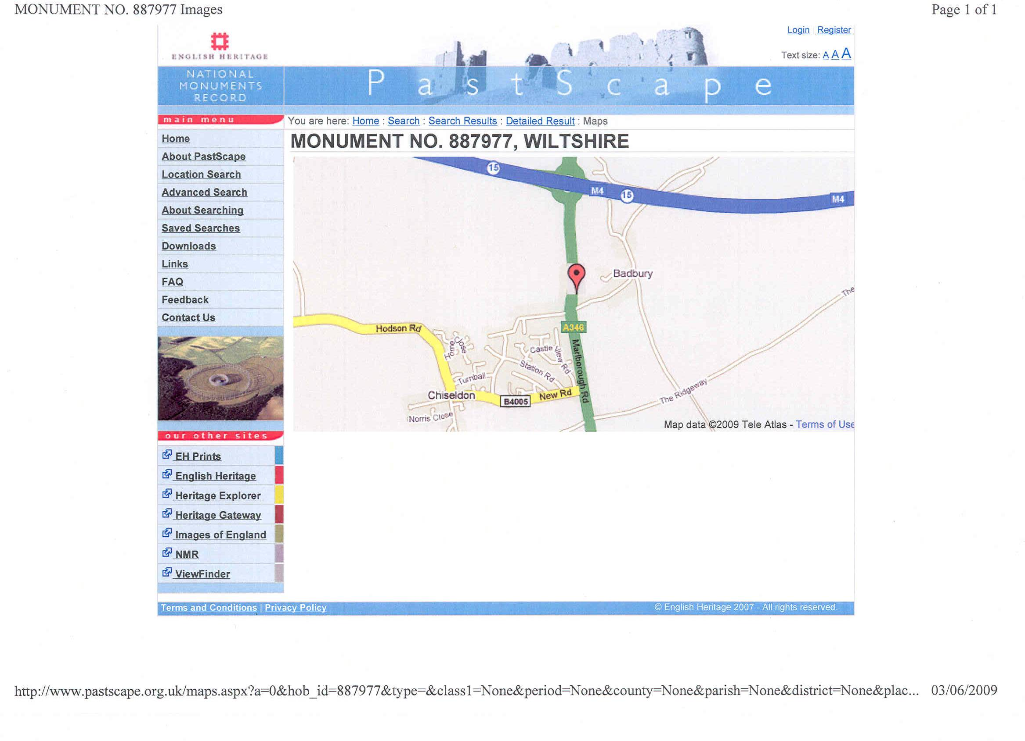

Evidence - Archaeological Finds 2
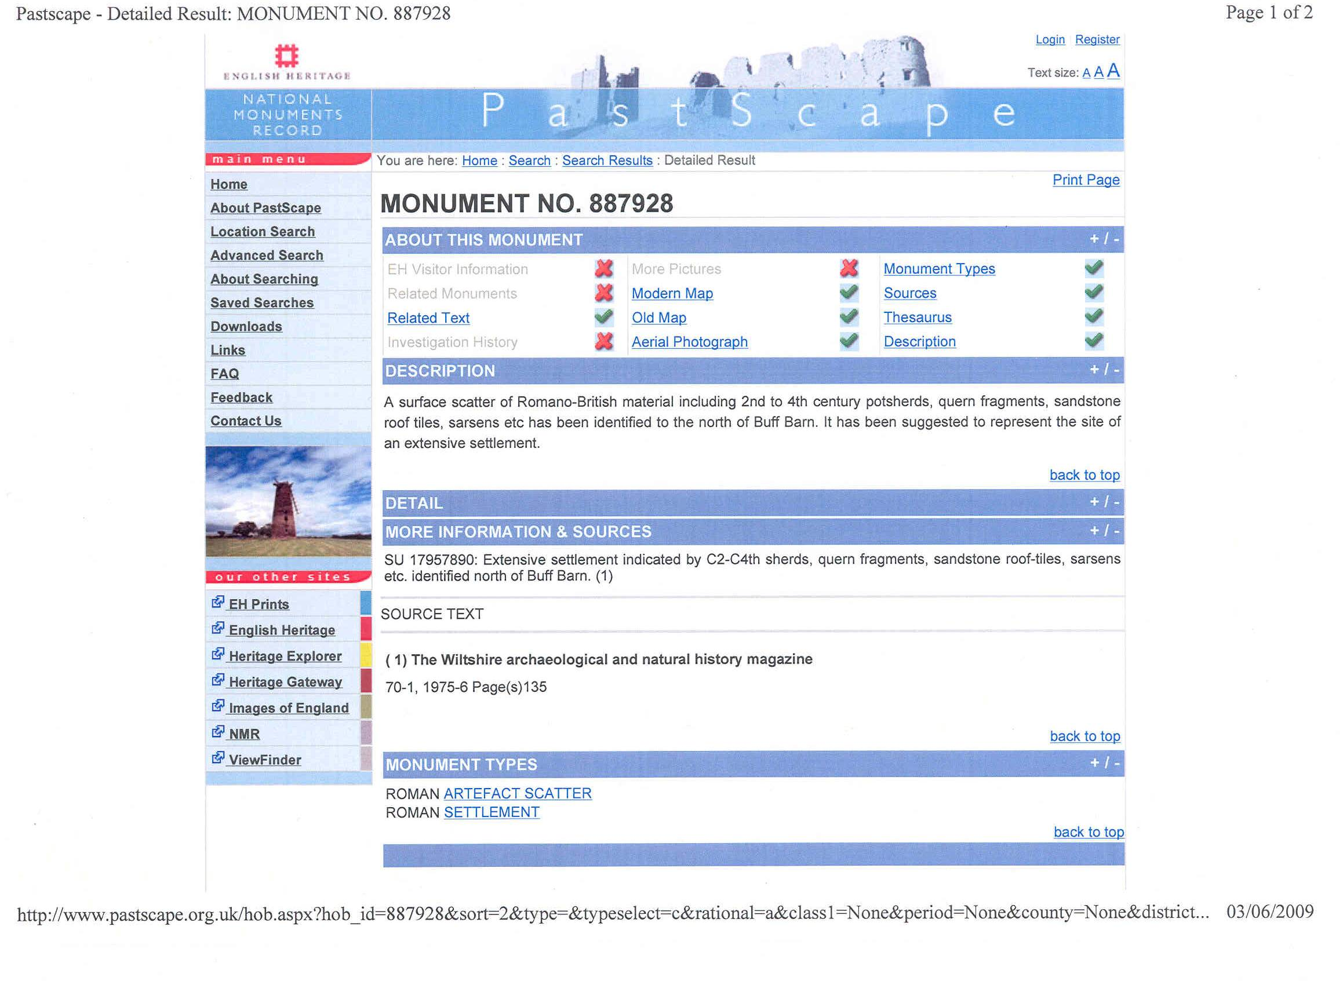

Evidence – Archaeological Finds 2
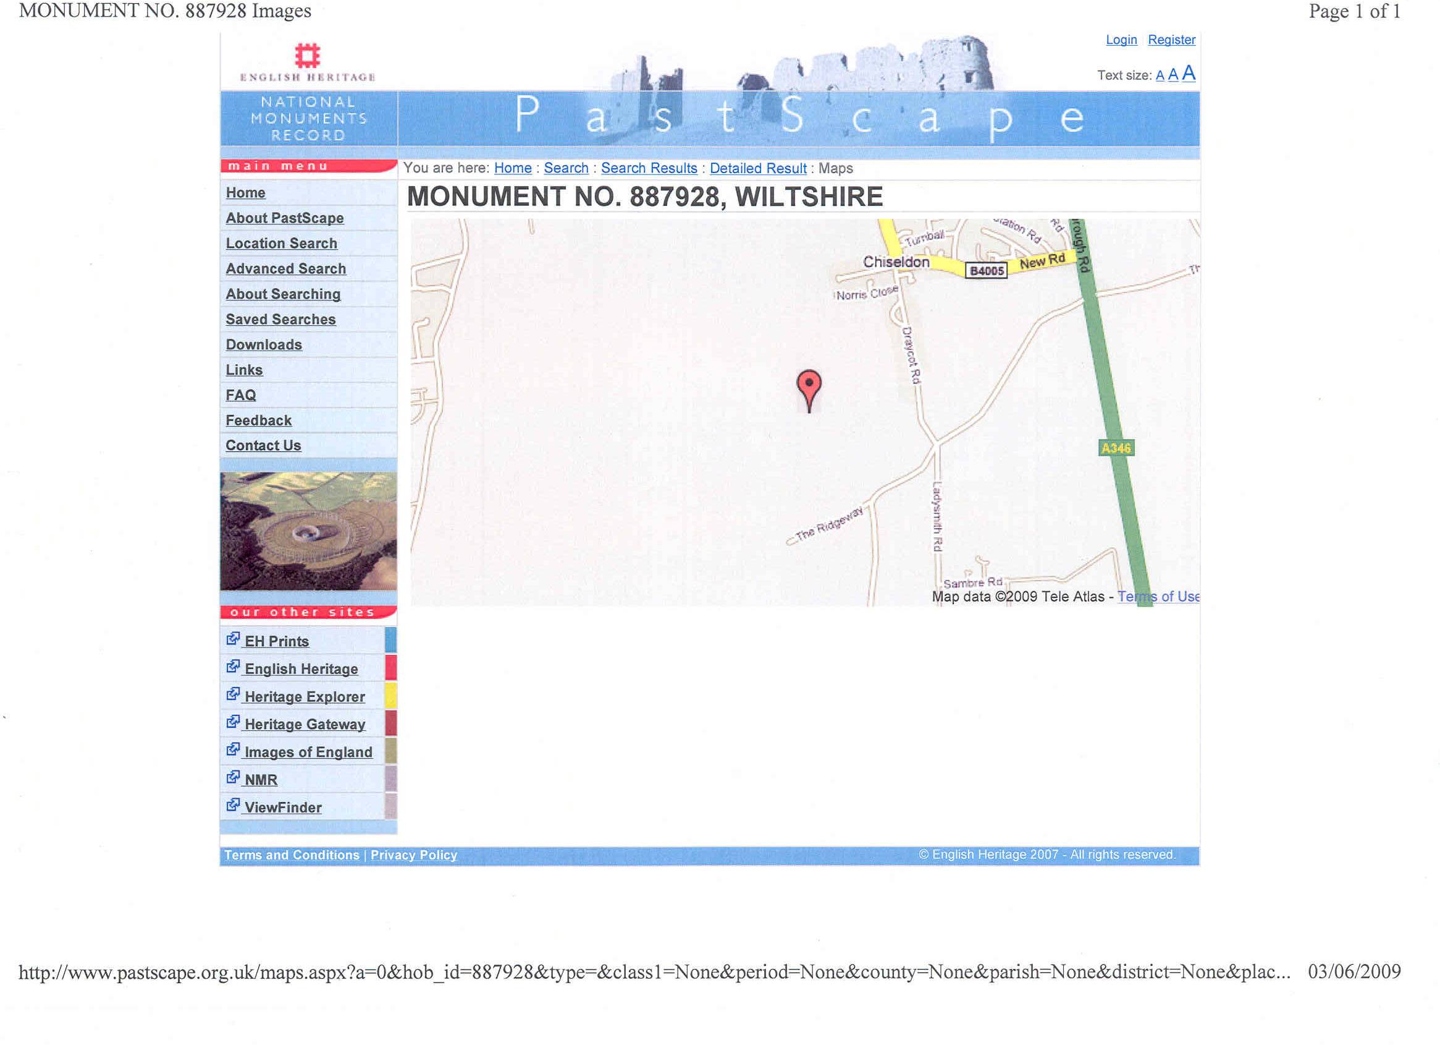

Evidence – Archaeological Finds 3
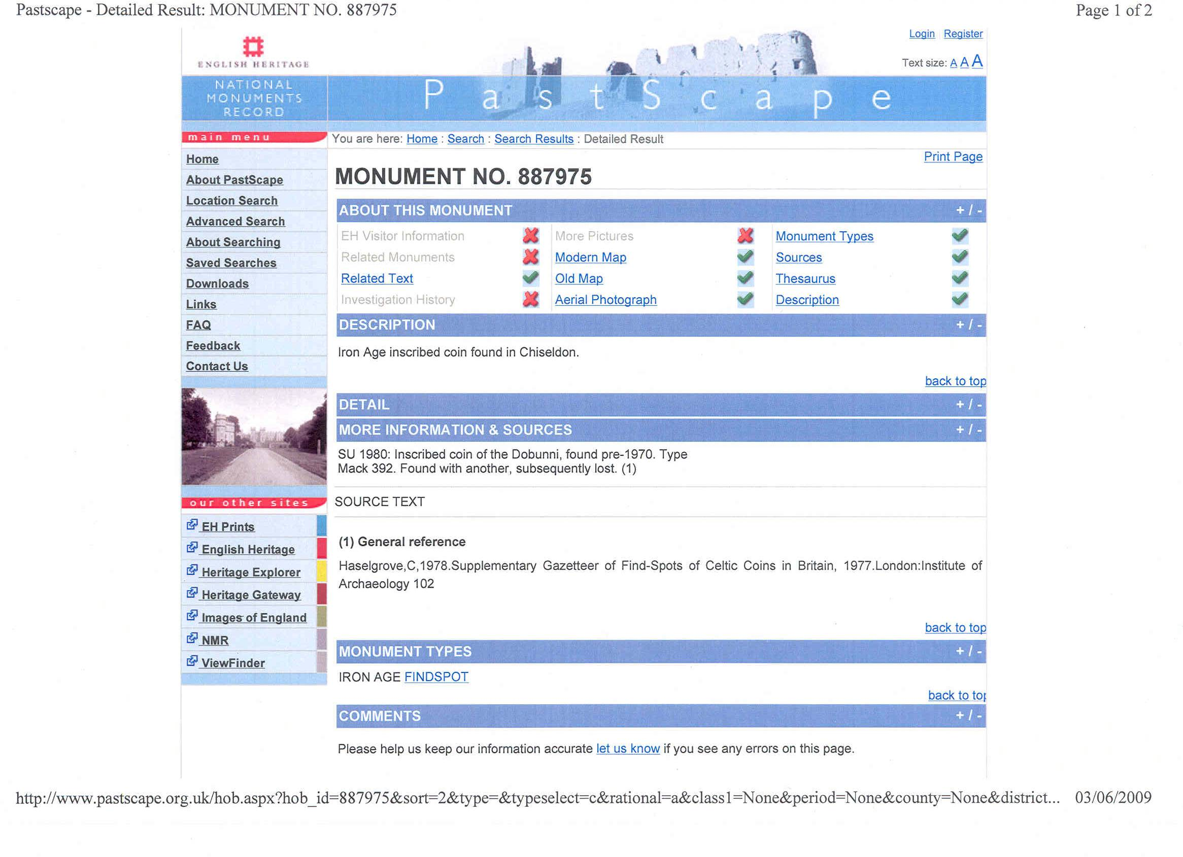

Evidence – Archaeological Finds 3
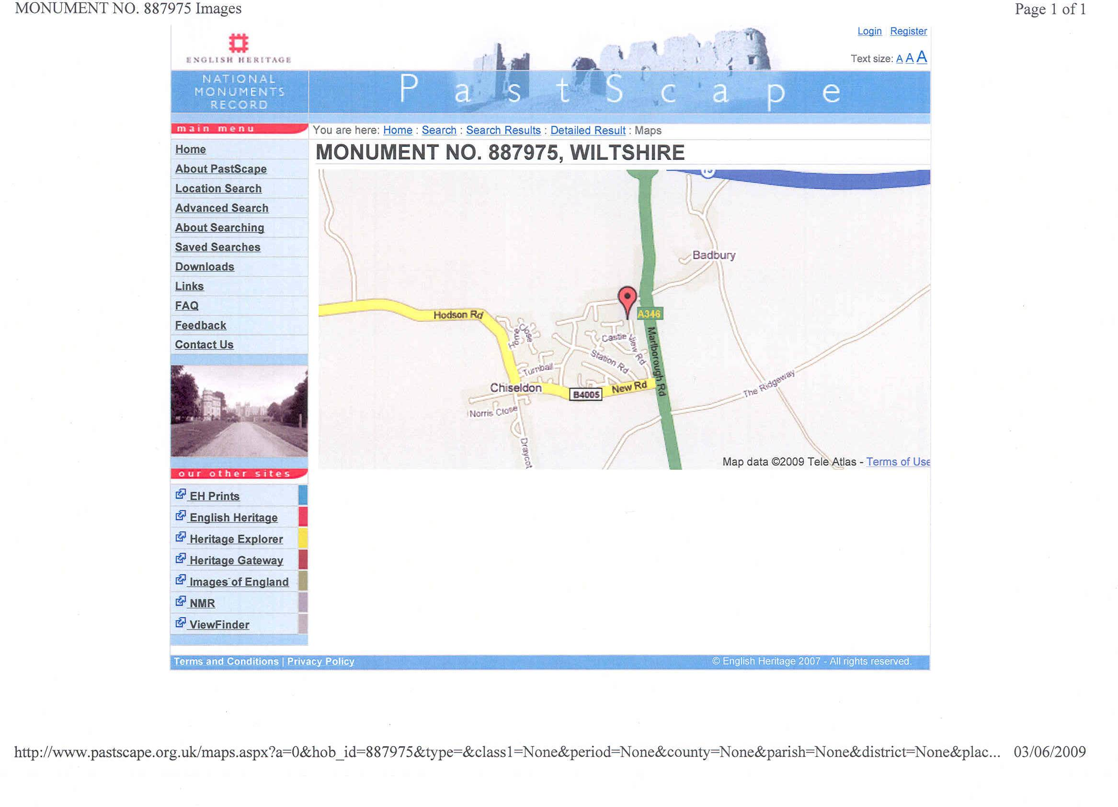

Evidence – Archaeological Finds 4
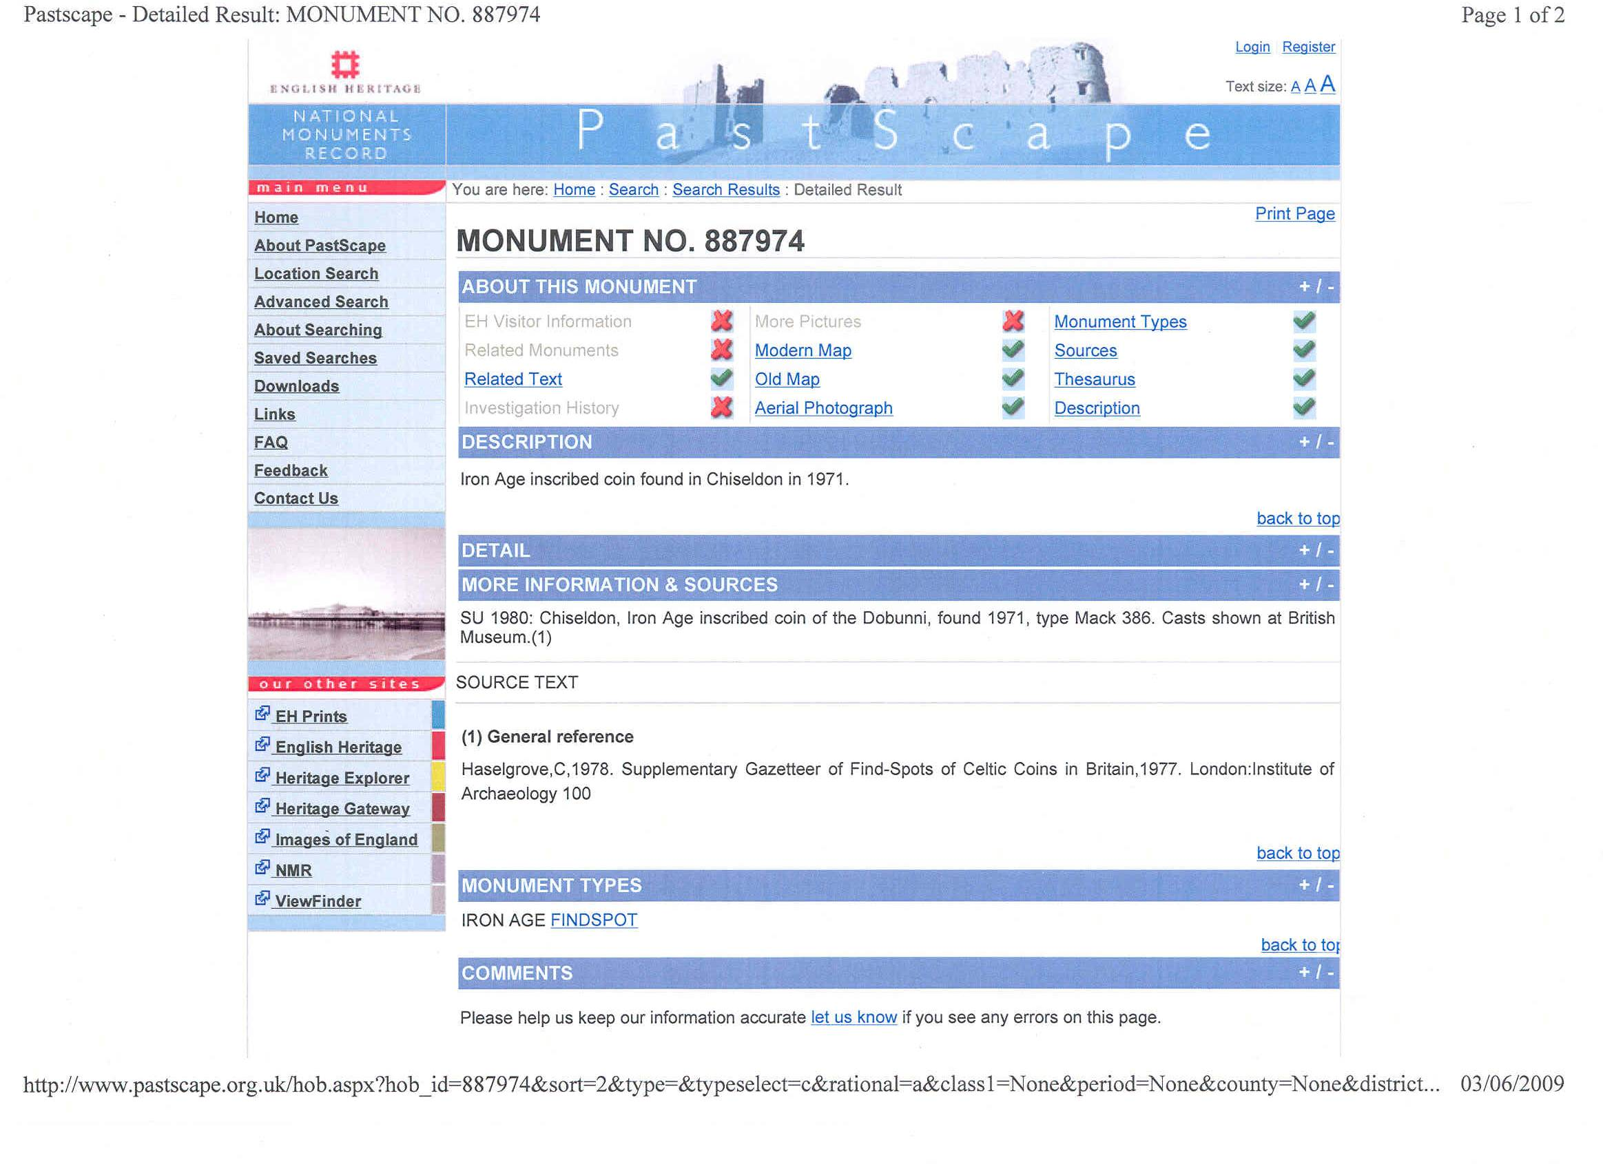

Evidence – Archaeological Finds 4
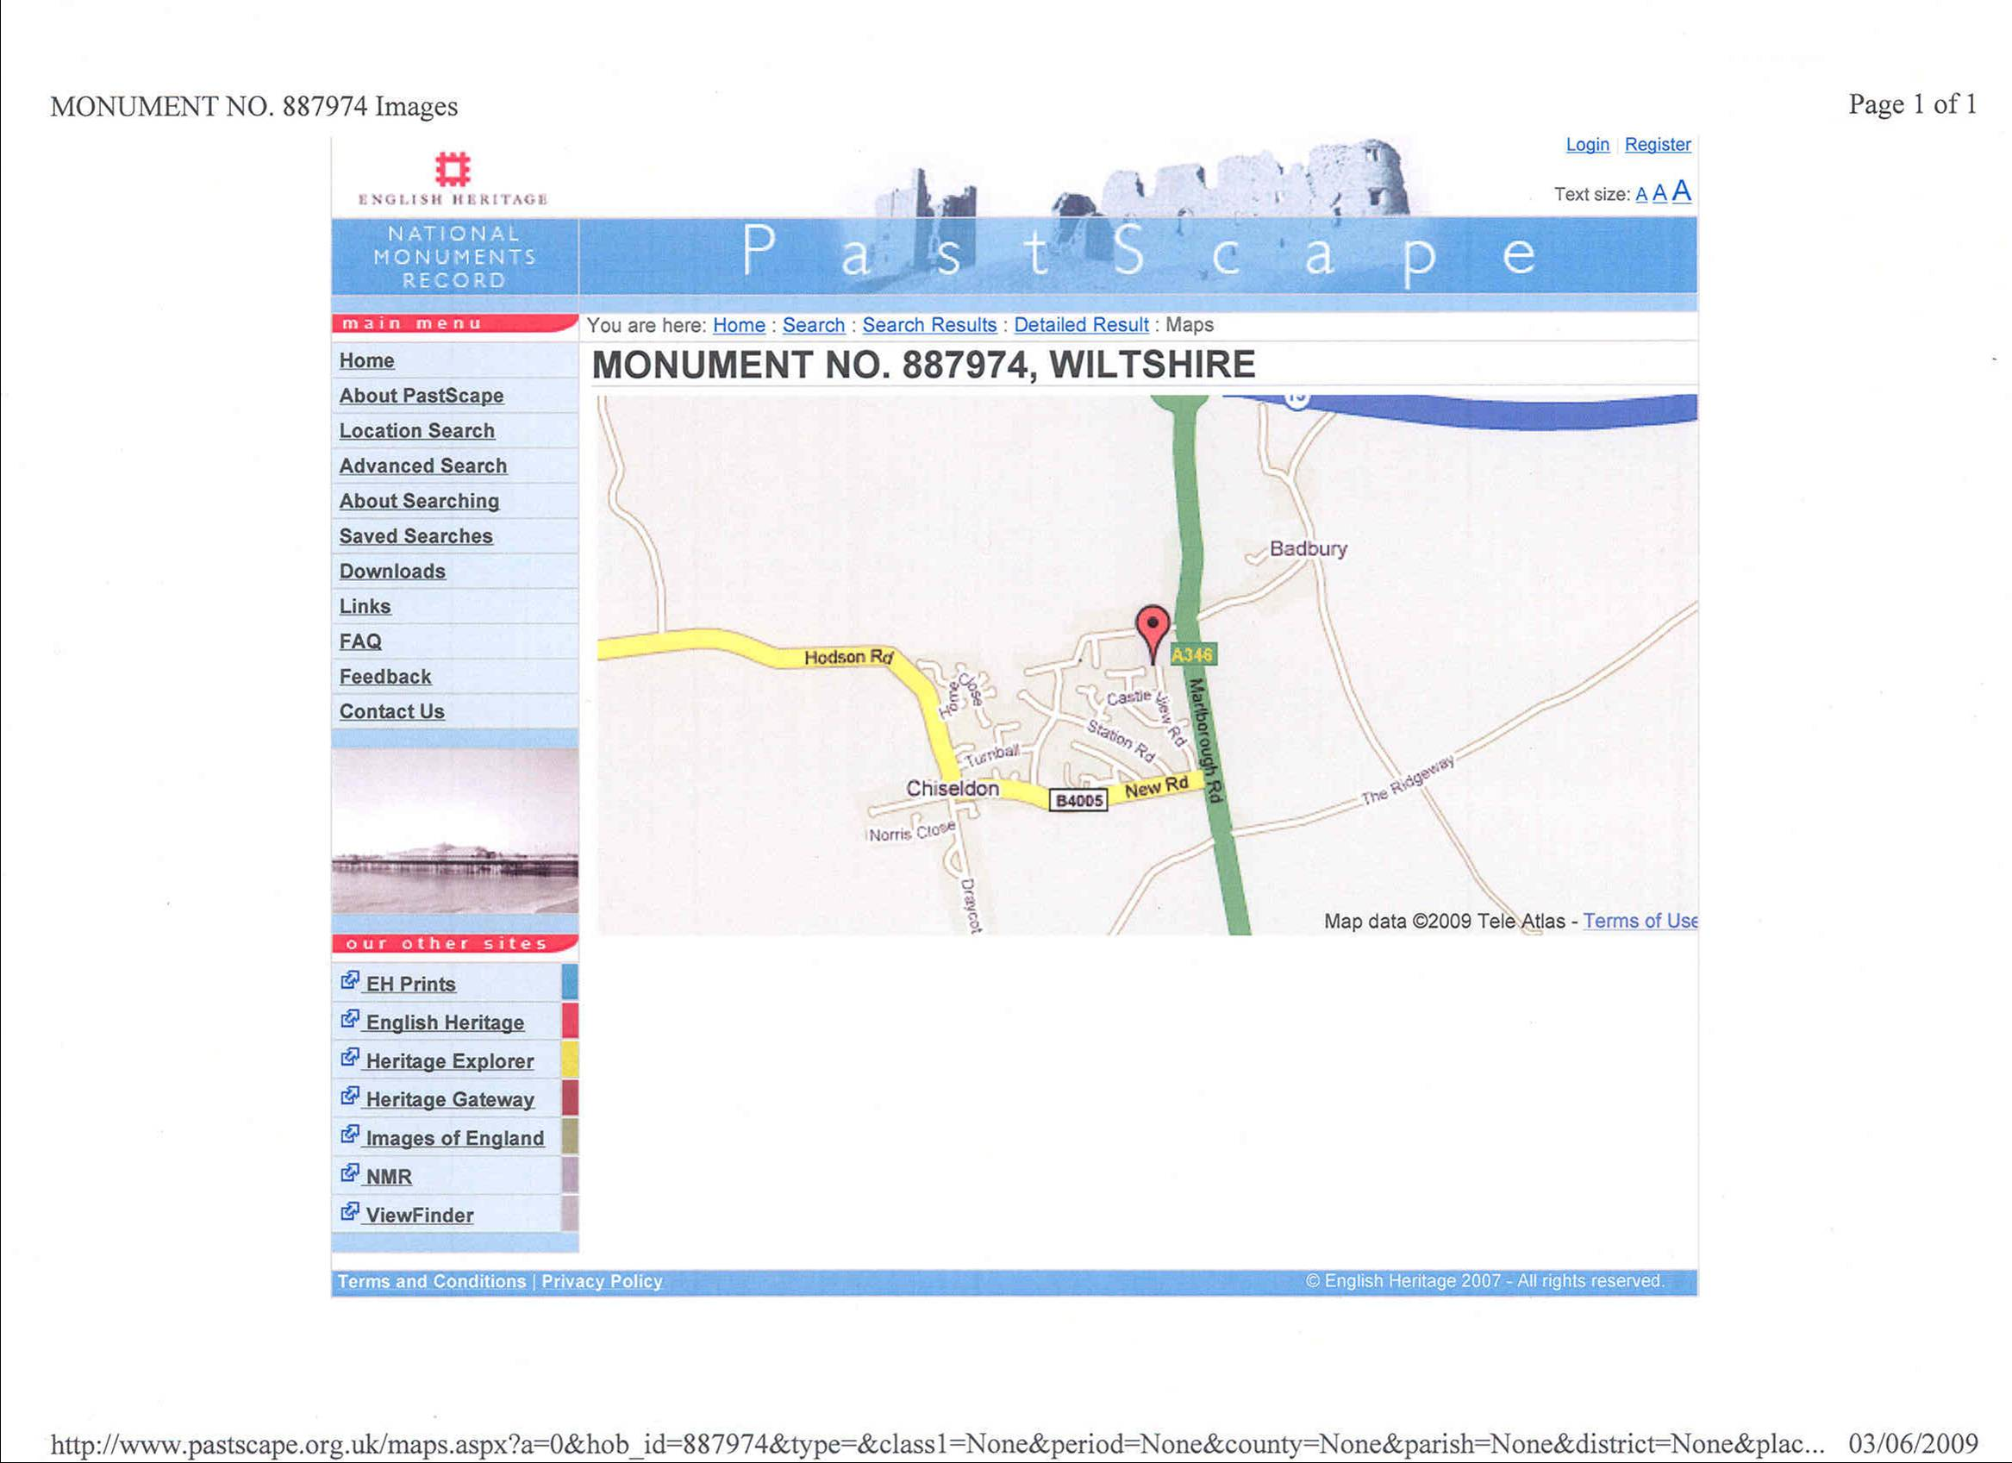

Evidence – Archaeological Finds 5
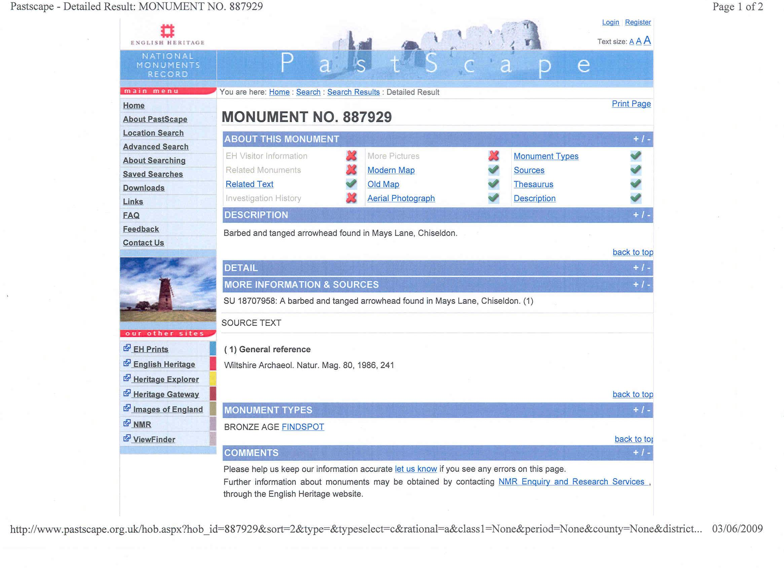

Evidence – Archaeological Finds5
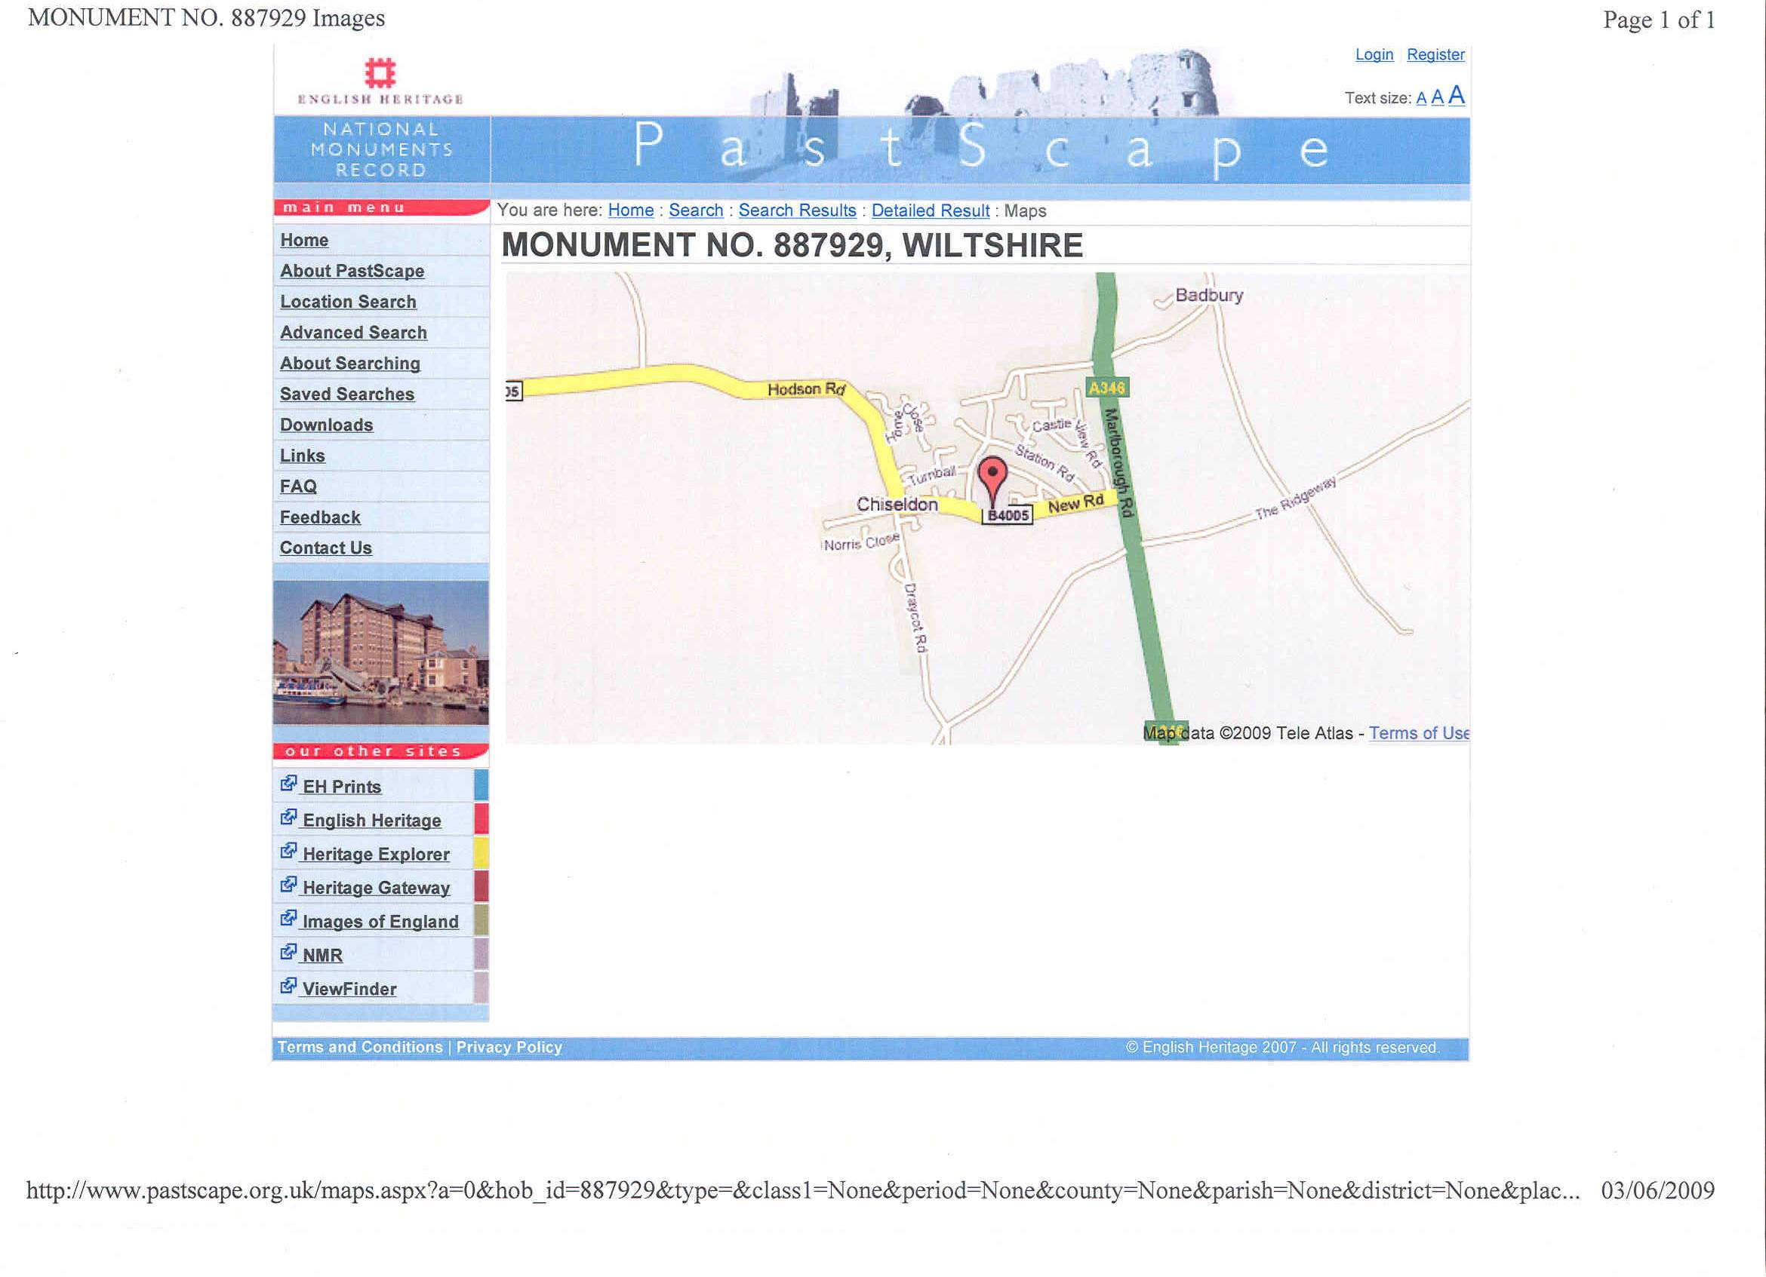

Evidence – Archaeological Finds 6
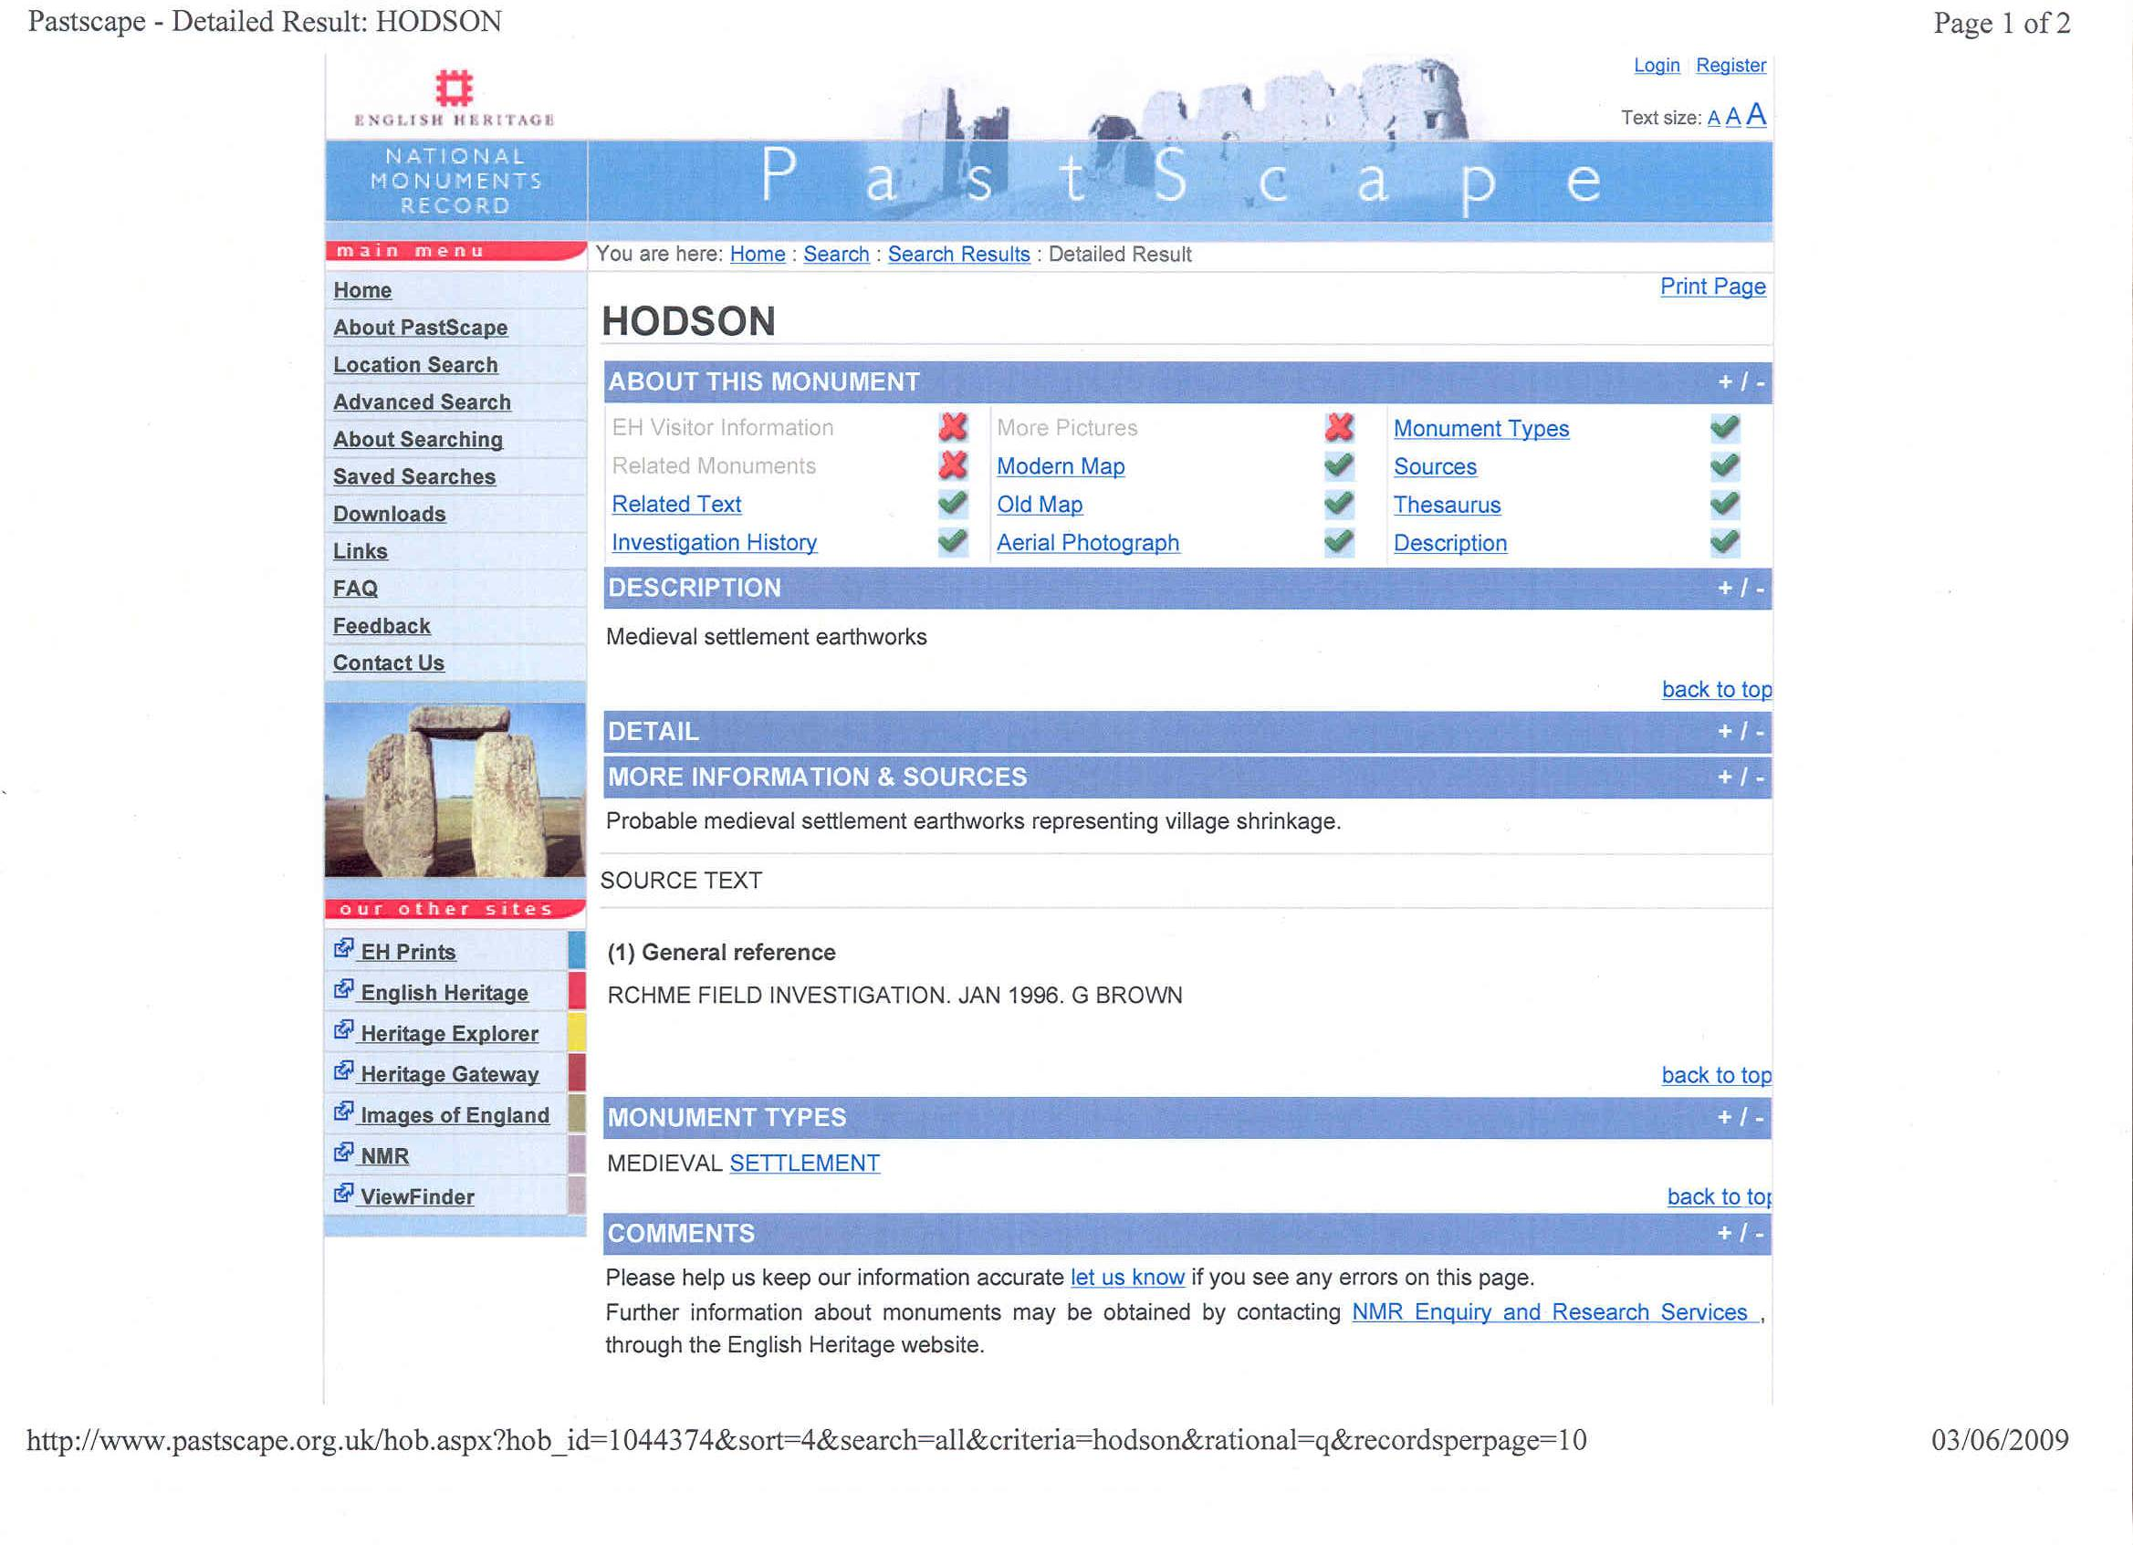

Evidence – Archaeological Finds 6
