Who was Charles Darwin?

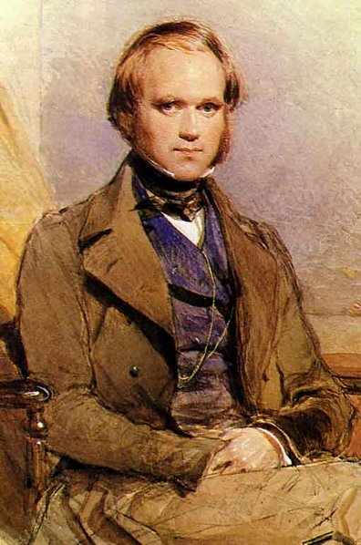

Charles Darwin was born 200 years ago on 12 February 1809. His family was wealthy and Darwin always had plenty of money during his life. As a boy, he hated school but loved playing outdoors and collecting beetles. He and his brother did chemistry experiments in a shed in their garden which they called the ‘lab’. His father wanted Darwin to be a doctor when he grew up, and said to him ‘you care for nothing but shooting, dogs and rat catching and you will be a disgrace to yourself and all your family.’

Darwin went to study medicine at Edinburgh university in Scotland when he was 16. He hated seeing people in pain on the operating table and left after two years. He then went to university in Cambridge. His plan was to work in a church as a vicar. But his real interest was still nature and he loved to be outdoors. At the age of 22, he was given the chance to travel the world on a ship called the Beagle.

His job was to record all the plants and animals that he saw during the trip. The trip lasted for five years! He collected thousands of fossils, plants and animals that had never been seen before in Britain.

When he finally returned to England, Darwin had lots of ideas about what he had seen. He set out to explain the way he thought everything in nature was linked together. His BIG idea was that animals and plants were not created by God, but had slowly developed over millions of years. This BIG idea was called the theory of evolution. He spent the next twenty years working on his ideas in his house in Kent, often in his garden. He continued to collect thousands of specimens such as insects and flowers. He spent hours patiently experimenting with the pollen from flowers, for example, and watching cucumber plants climb. He used a microscope and magnifying glasses to study insects and plants. All these experiments helped him to explain why his BIG theory about nature must be right.

Darwin’s typical day included reading, walking with his dog, listening to his wife, Emma, read to him and of course, experimenting. He also wrote a lot each day. He was very organised and careful about his work. He wrote a huge number of letters in his lifetime (about 14,500!) and he also wrote important books and articles. His most important book was called ‘On the Origin of Species’ which was published in 1859. This changed the way people thought about nature, animals and human beings.

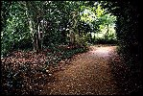
Darwin’s ‘thinking path’

Darwin had ten children, though only seven were still alive when he died at the age of 73. He lived with his wife and children at Down House, just outside Bromley. The house was quite large with a very big garden and the family had servants. Although he worked almost every day on his writing and experiments, he suffered from ill health for most of his adult life. No-one is sure whether he had a particular illness, or whether he suffered from stress and overwork. Either way, as he got older, he spent much of his time sitting down and even had a kind of Victorian wheelchair that his children loved to play on.

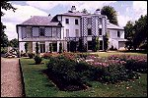
Down House

Darwin was quite a shy man and although he became very famous in his lifetime, did not enjoy the limelight and preferred to stay at home. He let his friends attend important meetings where his work was discussed.

Darwin died in 1882 and was buried in Westminster Cathedral, a huge honour. Most people agree that his ideas changed the world.

