SALLY’S SPECIAL HISTORY LESSON

Michael and James were cousins. They were in Year 2. One day they both came home from school to James’ house.

“We’re doing a topic about important things that happened in history.” said Michael to his little cousin Sally, who had only just started school.
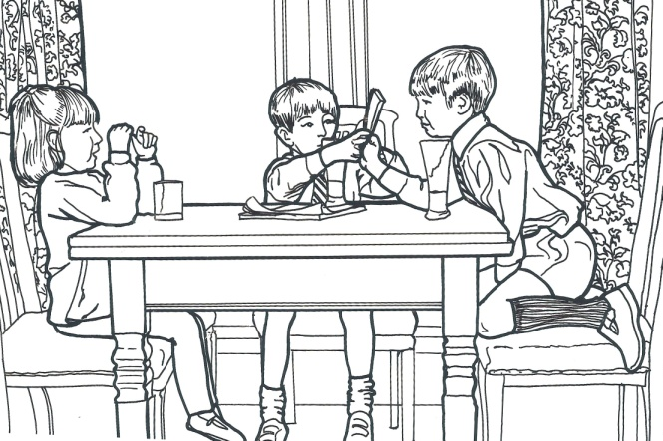
“What’s history?” asked Sally

“How should I know?” said Michael. “Mrs Stevenson our teacher only told us this morning.”

James said smugly. “Actually Sally, “Mrs Stevenson also said we were going to find out about some important historical people and events in our locality. We’re going to go for a walk with clipboards too. Mine’s a red one”

“What’s hysterical people?” asked Sally.

“How should I know?” said Michael again.

“I think it’s people who win X Factor or play football for England.” replied James.
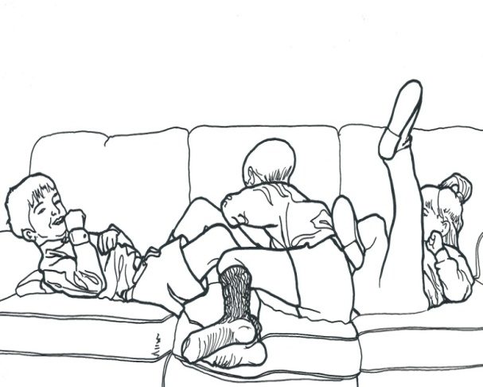
“Oooh, that sounds interesting” squealed Sally. “Mummy doesn’t allow me to watch X Factor.”

“That’s because you’re too young,” sniffed Michael “and you’re too young to do real work too. You can’t even read yet!”

This made Sally very cross. But then Michael smiled and began to tickle her and soon they were all giggling and playing on the sofa.

Just then, Michael’s dad came to collect him.

“What have you two been doing in school today?” he asked.

“They’ve been doing important X factories in the local hysterical city” shouted Sally

“Important what?” laughed Michael’s dad.

“Important people and events in our locality” chorused Michael and James together.

“What’s an event?” said Sally

“Oh be quiet” said James crossly. “I’m getting fed up with all your questions. Anyway, I’ve got a much more important question.”

“Uncle Gerry, what’s a locality and what’s historical?”

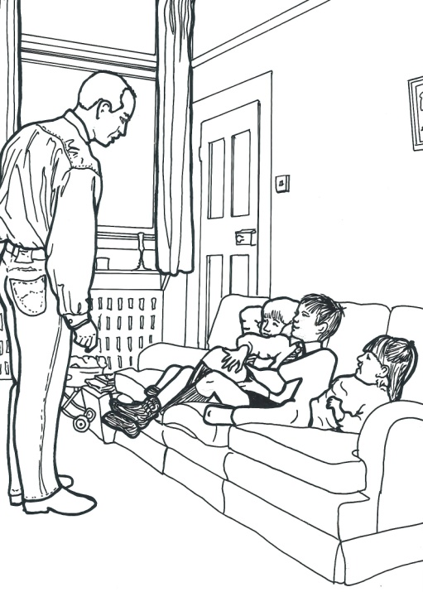
“Ahah,” said Michael’s dad. “A locality is the place near to where you and your friends live, or go to school, and historical means it’s all about things that happened a long time ago, before you or probably even I was born.”

“Coo” said Sally. “Do you mean that there were X factories and footballers in our road before I was born?”

Sally’s uncle roared with laughter.

“No Sally. An important event or person is something or someone from a long time ago in history that has changed or influenced the way we think, or the way we do things. I don’t think that the X Factor or England footballers have changed us that much. “

Michael looked at James in despair?

“How are we going to find out about something that happened before we were born?” cried Michael.
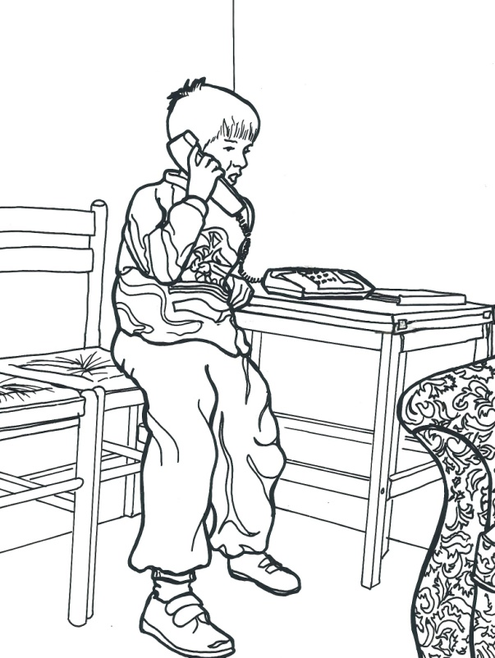
“I know, “said James “I’ll phone Aunty Louise. She’s a history teacher. She’ll know about history. Do you remember when she gave us those magnifying glasses and we pretended that we were detectives looking for clues. Aunty Louise told me that I would be a brilliant history detective. Anyway teachers know about everything,”

“Well how come Mrs Stevenson is making us find out about important things when she already knows about them?” muttered Michael darkly.

“I saw a book in school that had some photographs of our old school in it, and a painting of an old church” said James. “Do you think that will help us?”

“Perhaps Mrs. Stevenson has arranged a trip to the museum?” said Michael’s dad.

“What’s a museum?” piped Sally.

“It’s a place where you can see lots of objects and things that come from long ago in history.” answered Michael’s dad kindly. “Sometimes people visit old houses or ruined castles too. They’re great for imagining what used to happen in the olden days.”

“Wow, that would be a fantastic way to find out about history.” said Michael. “We could go to the library too. They might have some more books about things that have happened in our locality, or even old newspapers.”

When Michael had gone home, Sally felt very glum. It was all very well the boys talking about reading books and going to visit castles or museums and libraries, but how was SHE going to find out about important people and things that had happened even before her Mummy, or Daddy or Michael’s daddy was born? Sally put her chin on her hands and began thinking.

That night, when Mummy was putting her to bed, Sally suddenly asked

“How old am I Mummy?”

“Five years, six weeks, two days and three kisses” replied her mother.

“How old are you then?” asked Sally
“Well I’m nearly thirty two and your daddy’s thirty three.”

“Were you born in history?” asked Sally

“I suppose so” said Sally’s Mum, “but not very long ago in history.”

“What about Great Grandma then?” said Sally. “Was she born in history?”

“Well, Great Grandma is really old. She’s nearly 85 now, so that IS a long time ago in history.”

“Do you think that, because she’s so old, Great Grandma, will be able to tell me things about where we live, that not even you, or Daddy or Grandma and Grandpa will know about?

“Oh I should think so” said Mummy.

“So can we go and visit Great Grandma on Saturday please?”

With that, Sally snuggled down in bed and fell fast asleep.

On Saturday, Sally went to see her Great Grandma,

“Hello Great Grandma, how are you? Are you good at remembering important things that have happened and do you know lots about important people who used to live near our house? I am, but I’m even better after I’ve had a chocolate biscuit!”

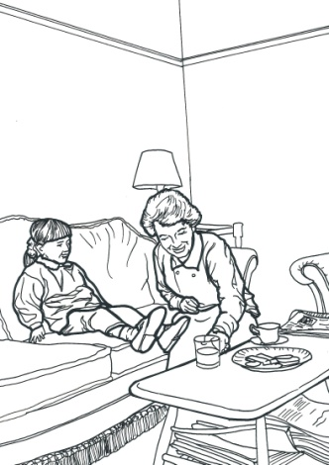
“Hello Sally,” said Great Grandma. “Yes I’m fine and I can remember most things, and I like chocolate biscuits too. But what do you want to remember?”

The two of them settled down in the front room with a big plate of biscuits, some tea for Great Grandma and a glass of juice for Sally.

“Tell me about some important people first of all” said Sally “and then tell me what used to happen here a long time ago..........

MY SCHOOL HISTORY PRIMARY PROJECT

My Name is ____________________________________________

Today’s date is __________________________________________

In the story that we read, Michael, James and Sally discovered many different ways to find out about what happened in their locality a long time ago. Can you remember what they were?

Michael, James and Sally discovered that we can find out about history by

_________________________________________________________
_________________________________________________________
_________________________________________________________
_________________________________________________________
_________________________________________________________
_________________________________________________________

__________________________________________
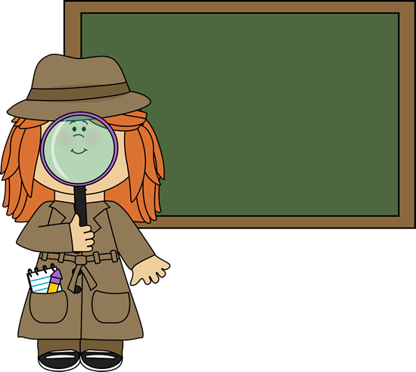
____________________________

MY SCHOOL HISTORY PRIMARY PROJECT

My Name is ____________________________________________

Today’s date is __________________________________________

In the story that we read, Great Grandma told Sally about important people from history who had lived nearby and important events in history that had happened nearby.

Our class is going to find out about an important person called

_______________________________________________________

who was born in __________________________________________

and who lived at __________________________________________

______________________________________ is important because

________________________________________________________

________________________________________________________

This is how we are going to find out about ____________________

We will _________________________________________________

________________________________________________________

________________________________________________________

________________________________________________________

MY SCHOOL HISTORY PRIMARY PROJECT

My Name is ____________________________________________

Today’s date is __________________________________________

In the story that we read, Great Grandma told Sally about important people from history who had lived nearby and important events in history that had happened nearby.

Our class is going to find out about an important event that happened nearby.

It was ____________________________________________________

The date of this event was ____________________________________

It is important because _______________________________________

__________________________________________________________

__________________________________________________________

This is how we will discover what happened ____________________

We will _________________________________________________

________________________________________________________

________________________________________________________

________________________________________________________

__________________________________________________________

__________________________________________________________________
__________________________________________________________________
__________________________________________________________________

__________________________________________________________________
__________________________________________________________________
__________________________________________________________________

__________________________________________________________________
__________________________________________________________________
__________________________________________________________________

__________________________________________________________________
__________________________________________________________________
__________________________________________________________________

__________________________________________________________________
__________________________________________________________________
__________________________________________________________________

__________________________________________________________________
__________________________________________________________________
__________________________________________________________________

__________________________________________________________________
__________________________________________________________________
__________________________________________________________________

