Additional picture for slide 49

Slide 50
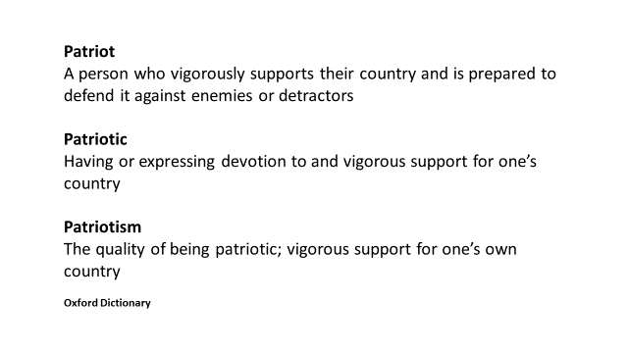
Slide 51
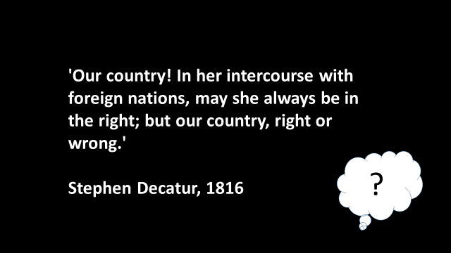
Slide 52
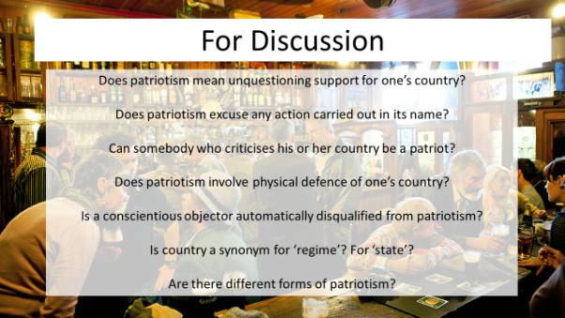
Slide 53
Union Jack background. Quotes from Edith Cavell over.
‘But this I would say, standing as I do in view of God and Eternity: I realise that patriotism is not enough. I must have no hatred or bitterness toward anyone’
Edith Cavell night of October 11/12th 1915

