**THE ‘CAMPDEN WONDER‘: What happened to William Harrison?**

This resource is a murder mystery with a difference. It relates to the disappearance of William Harrison in Chipping Campden, Gloucestershire in 1660. It led to a trial and three executions for murder before Harrison’s ‘wondrous’ reappearance two years’ later with an incredible story to tell. It will help pupils:

* understand the attitudes and beliefs of people in the 17th century
* develop their skills in analysing and evaluating evidence
* learn how to use evidence to support their conclusions

The materials can be used as part of a study of Early Modern Britain at Key Stage 3, as part of a GCSE study of Crime and Punishment or as an introduction to a study of Restoration England at either GCSE or A Level. Your pupils could take the role of modern detectives investigating a report of a missing person. All of the essential information is available in a larger print pdf version to print out on separate cards for pupils to use. The activities are designed for two or maybe three 30 minute lessons ; allow plenty of time for discussion.

**Starter activity**

Discuss with your pupils what would happen today when someone goes missing. Make use of a recent news story if possible. Get your pupils to brainstorm a list of methods which might be used to find the missing person and the different kinds of people who might become involved.

Then ask them to highlight any of the methods and people on their list which would have been available 350 years ago in the 17th century.

**Setting the scene**

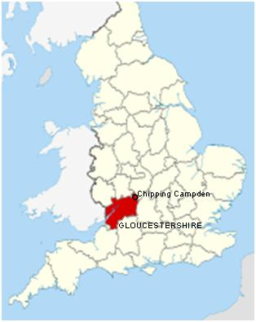Provide pupils with the following introductory information about this mystery:

It is Thursday 16th August 1660 in the first year of King Charles II’s reign. It is evening in the small market town of Chipping Campden in Gloucestershire. An anxious wife is worried that her husband, William Harrison, has not returned home....

William Harrison was 70 years old and worked for the local landowner. He had gone to the village of Charingworth, two miles away, to collect rent money from some of the landowner’s tenants. When he had not returned by 9pm, Mrs Harrison sent John Perry, their servant, to look for him. When she woke up the next morning, John Perry had not returned either....

Ask your pupils to briefly discuss what they think happened to William Harrison :

* Do they suspect foul play? Can they suggest any reasons why anyone might have meant him harm? Do they have any suspects? Or do they think there is a perfectly innocent explanation?
* Ask them to consider the strength of the evidence on which they are basing their conclusions (which at this stage are purely speculation).
* What more do they need to know to find out what really happened?

**What happened next**

Provide your pupils with the next part of the story :

Mrs Harrison asked her son, Edward, to go looking for her husband and servant. On the way to Charingworth, he met John Perry. Perry told Edward that he had not been able to find William.

They went to Ebrington where one of the tenants said he had seen William Harrison the night before. Then they went to Paxford but no-one there had seen him.

They decided to go home. On the way they heard that a poor woman had found some of William Harrison’s clothing by the side of the road between Chipping Campden and Ebrington. They found her and she showed them :

* a hat ; it had been cut by a knife
* a comb and the collar from a jacket ; they were bloodstained

Edward confirmed that they belonged to his father. They went with the poor woman to the place where she had found them. They looked all around but could not find a body.

When they got back to Chipping Campden, they explained what they had found. The townsfolk carried out an extensive search of the area but could not find William Harrison’s body.

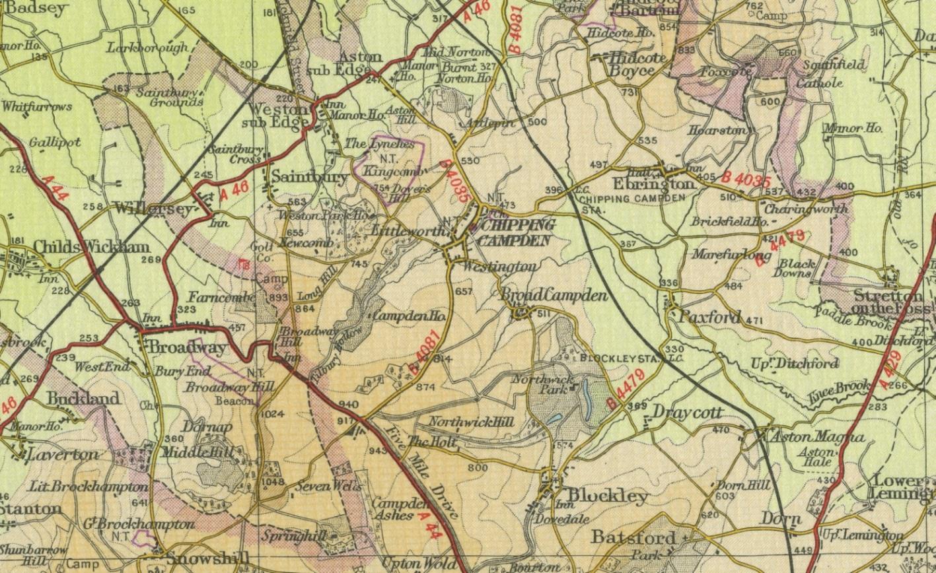

Ask your pupils to look again at the questions at the bottom of page 1. In the light of the evidence they have just studied, what do they think now?

**The murder trials**

Rumours quickly spread that John Perry murdered William Harrison to steal the rent money he had collected (about £23 – which was twice the annual salary for a servant). Perry was questioned by the local magistrate. In September and the following spring John Perry, his brother Richard and his mother Joan were put on trial for robbery and murder. John Perry was the key witness.

A 2oth century map of Chipping Campden and the surrounding villages

The main evidence which was presented to the judge and jury is shown on the next page and a half. Your pupils could, working in groups, take the role of members of the jury. Give them a copy of the map and the evidence on separate cards; they should examine them carefully before deciding on their verdict: were John, Richard and Joan Perry guilty or not guilty (‘beyond all reasonable doubt’) of robbery and murder?

Remind them that there was only one punishment for murder in the 17th century: death by hanging.

**What John Perry told the local magistrate on Saturday 18 August, two days after Harrison’s disappearance:**

John Perry said that after Mrs Harrison had sent him to look for William, he met a man called William Reed at Campden Field on the road to Charingworth. John told William that he was looking for his master but was worried that it was getting dark so he was going back to Harrison’s house to get a horse. Then he met another man called Pierce. Afterwards Perry returned to the Harrison house and rested for an hour in the chicken coop. Then at midnight he started walking towards Charingworth but it was very misty and he got lost. He spent the rest of the night under a hedge.

When he woke up early on Friday morning, he walked to Charingworth and went to Edward Plaister’s house. He told him that he had seen William Harrison the day before and paid him £23. Then Perry went to William Curtis’ house. Curtis said that Harrison had called at his house but he hadn’t seen him because he was out at the time. Then, at about 5am, Perry started walking back to Chipping Campden and met Edward Harrison on the way ...eHe

* What further questions would your pupils like to ask John Perry ?

(The magistrate asked Perry two further questions : Why did he decide to go to Charingworth at midnight when he’d decided not to go earlier ? Perry said that it was much lighter at midnight because the moon was out. When he went back to the house, why didn’t he go inside to see if William had returned? Perry said that there was a light in his bedroom window which would not have been there so late at night if he had been home.)

* Is there anyone else your pupils would like to question ?

(William Reed, Pierce, Edward Plaister and William Curtis were all interviewed and confirmed what Perry had said about them)

**What John Perry told the local magistrate on Friday 24 August :**

After the interview on 18 August, Perry was kept in custody. Rumours spread that he knew who had murdered William Harrison. Perry asked to speak again to the magistrate.

Perry said that William Harrison had been murdered but he hadn’t done it. Eventually, after further questioning, he said that his mother Joan and his brother Richard had killed him. He said that they kept asking him to help them steal money from Harrison, by telling them when he was going out to collect rent money. On Thursday 16 August, after Mrs Harrison had sent him out to look for William, he had met his brother Richard outside the house. They walked along the road towards Charingworth and John told him that Harrison had gone into a field called the rabbit warren. Richard went into the field to look for him but John stayed outside. After a while John went into the field and saw his mother and brother standing over William Harrison. He witnessed Richard strangle Harrison. Then Richard took a bag of money from Harrison’s pocket and gave it to their mother. John and Richard then took Harrison’s body and threw it into a cesspit.

John walked towards Chipping Campden, met John Pierce, and returned to the Harrison house where he rested in the chicken coop. On the way he took Harrison’s hat, collar and comb, cut them with his knife and threw them on the road.

* What would your pupils have done next if they had been the magistrate ?

(The magistrate ordered that Joan and Richard Perry should be arrested and questioned. The cesspit was thoroughly searched but nothing was found)

**John Perry had more to tell the magistrate :**

It was well known in the town that William Harrison’s house had been burgled the year before. £140 had been stolen from an upstairs room but the thief had never been caught. The magistrate asked John if he knew anything about it:

Perry said that his brother Richard stole the money. He told his brother which room the money was in and where he could find a ladder to reach the window. Richard told John that he had stolen the money while John was at church and had buried it in the garden.

John also said that after the robbery he had made up a story about being attacked by two men with swords. He did it so that people would believe that they were the thieves who had stolen the money.

Richard Perry’s garden was searched but no money was found.

**Joan, Richard and John Perry were interviewed by the magistrate on Saturday 25 August :**

John repeated his account of how his mother and brother murdered William Harrison. Joan and Richard both denied it and said that they were completely innocent.

While they were being taken back to Chipping Campden a roll of cloth tape fell out of Richard’s pocket. John immediately said that Richard had used it to strangle William Harrison.

The next day, Sunday 26 August, they went to church to talk to the priest. When they passed Richard’s house, two of his children rushed out to see him – immediately they both had nosebleeds (this was believed to be a sign of being in the presence of a murderer).

**What Joan, Richard and John said during their trial in the following spring :**

Joan, Richard and John Perry were put on trial for robbery and murder in September 1660. The trial was stopped because there was no body. A second trial opened in the spring of 1661, even though nothing more had been found.

Joan, Richard and John Perry all pleaded not guilty. John said that what he had told the magistrate on 24 August was not true; he said that he was insane at the time and didn’t know what he was saying.

* Ask your pupils to draw up two lists from all the evidence they have studied : clues that point *towards* and *against* their guilt
* Do any of their clues provide **proof** about what happened ?
* Ask each group to announce, and explain, their verdict to the rest of the class.

**The verdict and sentence**

Now tell your pupils what really happened .....

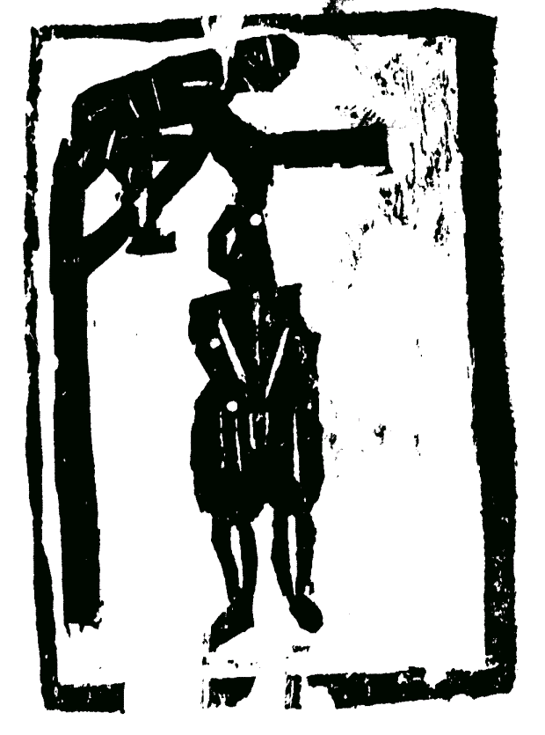

Joan, Richard and John Perry were all found guilty of robbery and murder. They were sentenced to death by hanging.

They were taken to Broadway Hill, just outside Chipping Campden:

* Joan was hanged first – some people said she was a witch who put her sons under a spell to stop them confessing
* Then Richard was hanged – he still insisted that he was innocent and begged his brother to tell the truth
* John was hanged last – he said he knew nothing about William Harrison’s death. His body was left hanging in chains until it decomposed.

But then two years after William Harrison’s disappearance....

**The ‘Campden Wonder’**

In 1662 William Harrison walked into Chipping Campden – alive and well! He had an amazing story to tell:

**After his return to Chipping Campden in 1662, William Harrison wrote an account of what happened to him for the local magistrate:**

After I collected rent in Charingworth, I started to walk home. On the way, I was met by a man on a horse. He wounded me with his sword. Another man grabbed my collar and stabbed me. Then another man arrived. They tied me up and took me away on a horse.

Four days later, we reached a place called Deal *(in Kent)* on the coast. They sold me to a man called Wrenshaw. He put me on a ship and treated my wounds. I was on the ship for about 6 weeks. Then I was transferred to a Turkish ship. When we landed, I was taken to a prison with several other men. We were questioned for about 4½ days about our trades and professions.

I was sold to an 87 year old doctor who lived near Smyrna *(in Turkey)*. He gave me a silver bowl and I ran his distillery *(probably making herbal medicines)* and collected cotton. I was there for a year and ¾ until my master died. Then I escaped to the nearest port, a day’s journey away. I sold my bowl to get on a ship which sailed to Portugal. The sailors hid me below deck for the whole voyage. When we landed, I had no money. I walked into Lisbon and met a man from Lincolnshire. He gave me food, drink and money – and he introduced me to the captain of a ship which was sailing for England. We set sail and landed at Dover. Then I went to London and travelled home.

This is a true account of my sufferings and deliverance, by the mercy and goodness of God and our Lord Jesus Christ.

Ask your pupils :

* Is there anything you find difficult to believe about Harrison’s story? (remember he was 70 years’ old in 1660)
* Why do you think he wrote his story down for the local magistrate?
* Does Harrison’s story prove *anything* about what happened in Chipping Campden in 1660?
* Does this mystery tell you *anything* about life in the 17th century?

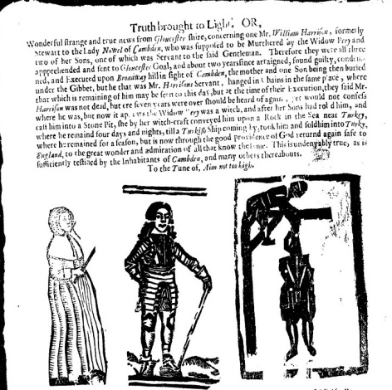**Some conclusions**

News of William Harrison’s ‘miraculous deliverance’ spread quickly and attracted considerable interest at the time. Several contemporary pamphlets and ballads were written about it; for example see Tyus’ Broadside Ballad thought to have been published in London in 1662:

* a facsimile held in the Bodleian Library <http://ballads.bodleian.ox.ac.uk/view/sheet/23349>
* the lyrics <http://www.campdenwonder.plus.com/Ballad.htm>

In the 20th century several novels and plays, loosely based on this now largely forgotten case, were written ; the most well known is probably ‘The Campden Wonder’ by John Masefield (1907). Several recent books have also been

Part of Tyus’ Broadside Ballad

published including ‘Gloucestershire Murders’ by Linda Stratmann (Sutton Press 2005).

So what are we - and our pupils – to make of this strange murder mystery without a murder?

* it is clearly what we would call today a miscarriage of justice ; three innocent people were executed for a murder which did not take place
* we will never know what motivated John Perry to lie and implicate his mother and brother
* we will also never know how much, if any, of William Harrison’s story is true ; at the very least the kidnapping of a 70 year old man to sell him into slavery sounds rather unlikely!
* perhaps its greatest value is to shed some light on contemporary attitudes and fears ; in particular :
  + fear of witches (the exploits of Matthew Hopkins the ‘Witchfinder General’ in the 1640s were still within living memory)
  + the danger of being kidnapped and sold into slavery (during the 16th and 17th centuries, Barbary Pirates, also known as Turkish or Moorish Pirates, raided towns and villages on the coast and seized hundreds of inhabitants to sell them as slaves or for ransom)
  + the idea of servants challenging their masters was seen, by the upper classes, as a serious threat to the social order

**Sources and acknowledgements**

The most easily accessible and authoritative source about these events is Peter Clifford’s Campden Wonder website <http://www.campdenwonder.plus.com/> It provides comprehensive information about all the people and places mentioned in the story as well as all the available contemporary source material, including the full text of [Sir Thomas Overbury's "True and Perfect Account" (1676)](http://www.campdenwonder.plus.com/Overbury.htm) from which most of these materials have been adapted. Overbury was probably the local magistrate who interviewed the Perrys and for whom William Harrison wrote his account.

I would like to thank Professor Jackie Eales of Canterbury Christ Church University for introducing me to this topic in a fascinating lecture which provided the inspiration for these materials. She is currently writing a book about the Campden Wonder.